**GRAPHIC ERA DEEMED TO BE**

**UNIVERSITY**



**MINI PROJECT**

**Online Voting System**

Name : Siddhant Bohra

Section : A

Semester : 6th

Class Roll No. : 56

Univ Roll No. : 2014881

Session : 2021-22

**ACKNOWLEDGEMENT**

I am extremely thankful to our Honorable Chairman Sir Prof. Kamal Ghanshala of GRAPHIC ERA DEEMED TO BE UNIVERSITY, DEHRADUN for providing all kind of educational and infrastructural support to the students.

I would also like to thank our head of the department, Dr D P Singh, and all other faculties of computer science engineering, head of the department and faculties of other departments and all other teaching and non-teaching staff of our collage for the most effective and most valuable guidance.

I hereby like to express my sincere gratitude and respect to my project mentor Dr. Surendra Kumar Shukla for his stimulating guidance and continuous supervision, monitoring and constant encouragement throughout the project completion.

I am obliged to my classmates for the valuable help and feedback provided by them in the completion of this project. I am grateful for everyone’s cooperation during the period of my mini project completion.

**ABSTRACT**

The aim of this project is to implement the typical voting system in our country through online mode, where people living away from their home state can give vote easily, without having to go back to their hometown which may hamper their career.

In this project, sample data which is similar to real world data is used. People can vote to their favourite candidate with just a few clicks anywhere and they anytime they want to. They just need to login using their voter card credentials, and they are good to go.

**INTRODUCTION**

In today’s world, which is full of career and politics, people face shortage of time so much that they even cannot afford leave from their offices just to visit their hometown and vote for their favourite representative. As a matter of fact more than 70% of the population which are not working in their voter card address do not vote. This leads to uneven voting and also sometimes results in unfavourable representative of that area.

Although there is a provision of ballot voting through postal services but people are lazy enough to do that too.

This project, **Online Voting System** focuses on the above mentioned problem. This project is a website based implementation which can be used by general public to vote for their favourite representative in just a few clicks and a login from anywhere in the country. They just need to enter their voter card credentials and they are good to vote.

This project is made by using **HTML, CSS, Bootstrap,** and **PHP**. **XAMPP** is used to trigger **localhost** and manage **myphpadmin** which consists of voter data in form of rows and columns, **mysqli** feature is used in PHP to establish connection between database and web-page and also to handle **SQL** queries. It comprises of login page which can be used to access the details of voters and to cast vote respectively by providing voter id and password.

Before first time login, the voters have to register/sign up on the website using their mobile, voter id, and aadhar details which they have provided to issue the voter card. Then after completion of the sign up they are free to vote and check their profile. There is also a separate panel for admin through which admin can manage the voters, candidates and can view results of the voting done at any given time and can also disable/enable voting rights for a person.

**ADVANTAGES OF**

**ONLINE VOTING SYSTEM**

1. Accessibility for each and every citizen as everyone has mobile phones.
2. Admin can also view the voting results via the access of such websites.
3. Admin can manipulate the candidate details and voter details if needed to do so.
4. Admin can disable the voting rights of all the people when voting schedule is over.
5. One voter can only cast one vote at a time, which leads to vote security.

**MOTIVATION**

For the motivation, during the pandemic I remember that elections took place in my hometown and at that time my grandparents used to live with me. They told me that since all my family members live in different states due to their jobs, a total of 24 votes were short from only our family. Also, this was my first time to give a vote which was ruined by pandemic.

So this motivated me to choose this project and to develop a online voting system so that no one has to face such problem in the future.

**SOME DETAILS REGARDING THE TERMINOLOGIES IN THE PROJECT**

**Ques : What is Full Stack Web Development?**

Full Stack Web Development refers to the development of both front end(client side) and back end(server side) portions of web application. A full stack web developer is the person who is proficient not only in Front-end but also in the Back-end languages.

**Ques : What is the importance of online voting system?**

Online Voting System is important in order to ensure maximum amount of votes by the general public as we know that in today’s world where career is over everything, most of the people in corporate world living in other states are unable to cast votes for their hometown.

**Ques : Which languages is/are used in this project?**

Front-End languages :

HTML - HTML is the language for describing the structure of Web pages.

CSS - CSS describes how HTML elements are to be displayed on screen, paper, or in other media.

BootStrap 5 - Bootstrap is a free and open source front end development framework for the creation of websites and web apps.

Back-End Language :

PHP - PHP is an open source scripting language. PHP scripts are executed on the server.

SQL - SQL is a standard language for storing, manipulating and retrieving data in databases.

**Ques : Why SQL is better to use for database management?**

SQL allows us to interact with relational databases through queries. These queries can allow you to perform a number of actions such as: insert, select, update and delete information in a database.

**Ques : How is a localhost created?**

Localhost is created in a system with the help of XAMPP webserver. Using it any system can be converted to a localhost. It also provides the features of myphpadmin, which is a database where data can be stored in the form of tables and can be accessed manually or using sql queries of using php implemented sql.

**Ques : How to use Query Language in Web Development?**

 Using PHP with the help of Mysqli functions we can implement queries in our web development. The Mysqli functions allows us to access mysql database servers.

**METHODOLOGY**

Initially I started with the rough sketches and rough wireframe of my website about how it will look and feel, and how different pages will be connected to each other.

Initially I developed the frontend for all the pages which were there in my rough wireframe. The frontend was developed using HTML integrated within PHP, the styling was done using predefined BootStrap 5 and external CSS. Initially the pages included were-

1. Welcome Page
2. Login Page
3. Profile Page
4. Voting Page
5. Logout Page

But then it occurred to me that there should also be an admin who can manage the database if required. So I added a admin panel with following privileges-

1. To view all the vote counts.
2. To add a new candidate.
3. To edit the details of an existing candidate.
4. To edit the information of a given voter.
5. To reset all the vote counts.
6. To disable the voting rights of all voters.
7. To enable the voting rights of all voters.

Adding all these privileges added new pages. Then I started with the backend of the pages. The backend is completely based on PHP. Since the navbars were constant for all the pages so two files which were header.php and footer.php were included in all the pages externally and they show different content when the user is logged in and when user is logged out. Then I built a sample database using 300 student details and gave them random generated voter id, phone number and aadhar details using Excel software formulae. The developed spreadsheet was exported as CSV(Comma Separated Variable) File. Then with the help of XAMPP I created a localhost, and XAMPP’s inbuilt MySQL server phpmyadmin to store my database so that it can be accessed using SQL queries using PHP’s mysqli feature.

For managing the login and logout sessions are used in PHP, pages except login and welcomepage can only be accessed when the user is logged in otherwise they will be redirected to the login page. To add more security the user will be logged out as soon as he casts his/her vote and won’t be able to get back to the voting page even after logging into his/her account, as one person can only cast one vote. It is in the power of admin to disable all the voting rights and enable all the voting rights.

The PHP uses SQL queries to execute the tasks such as login, voting, getting votes, resetting the votes. Also it has been taken care of that a single user cannot login at the same time from multiple browsers.

**WEBSITE IMAGES**

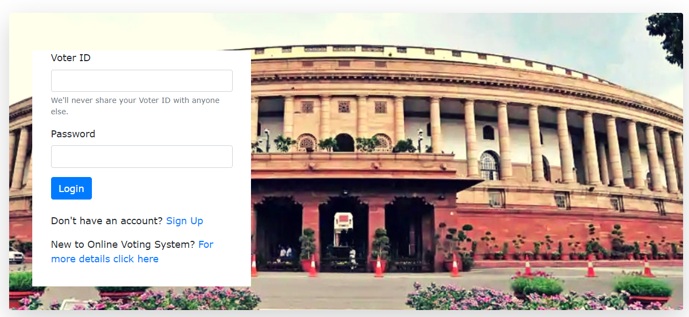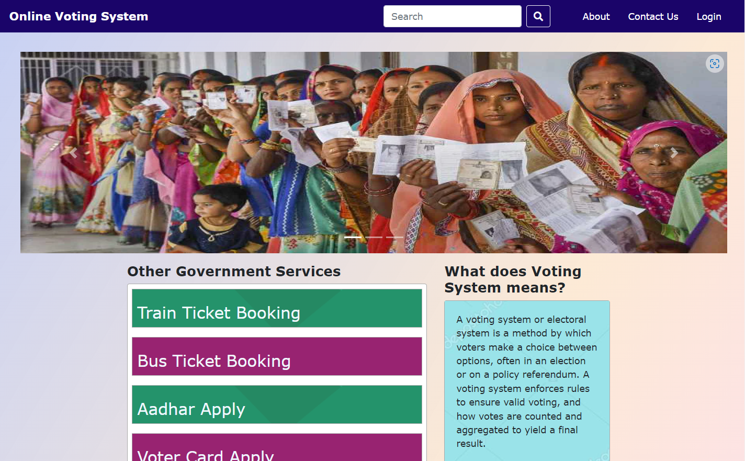

**Welcome Page Voter Login Page**

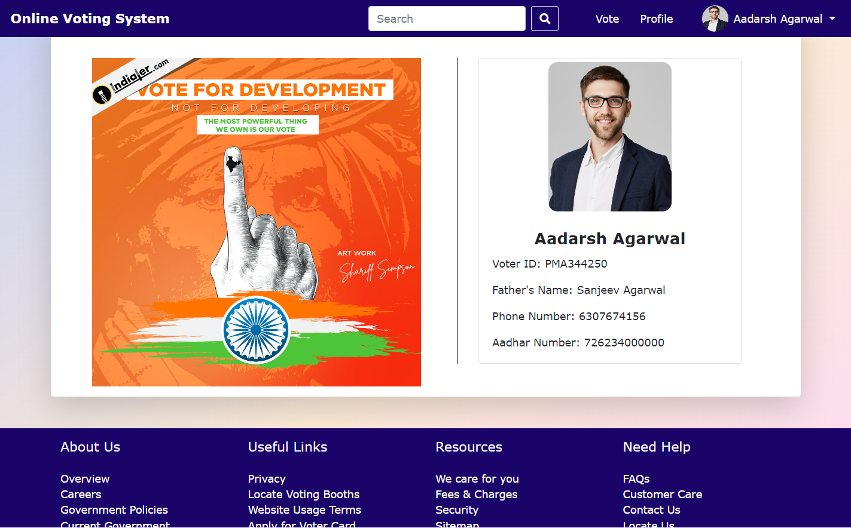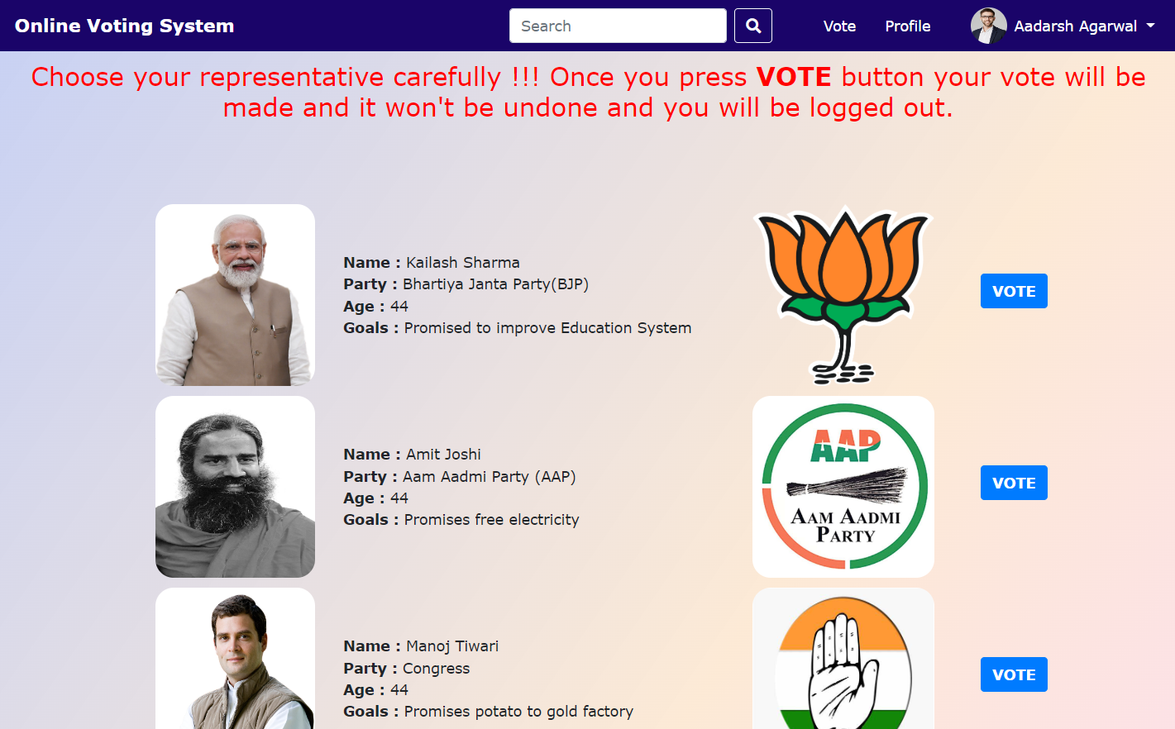

**Voter Profile Page Voting Page**

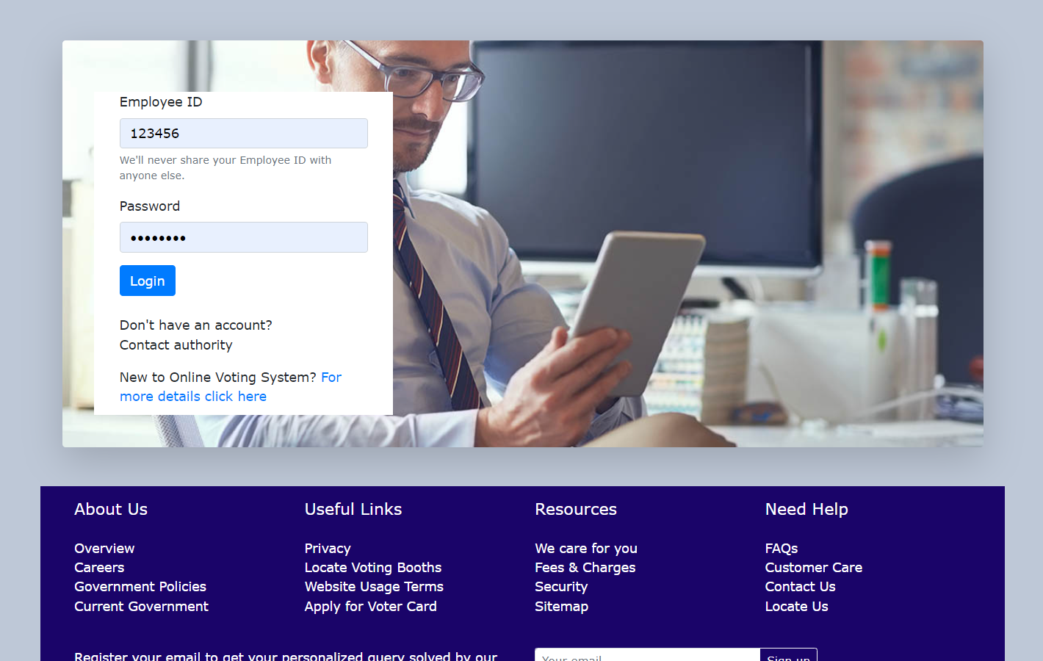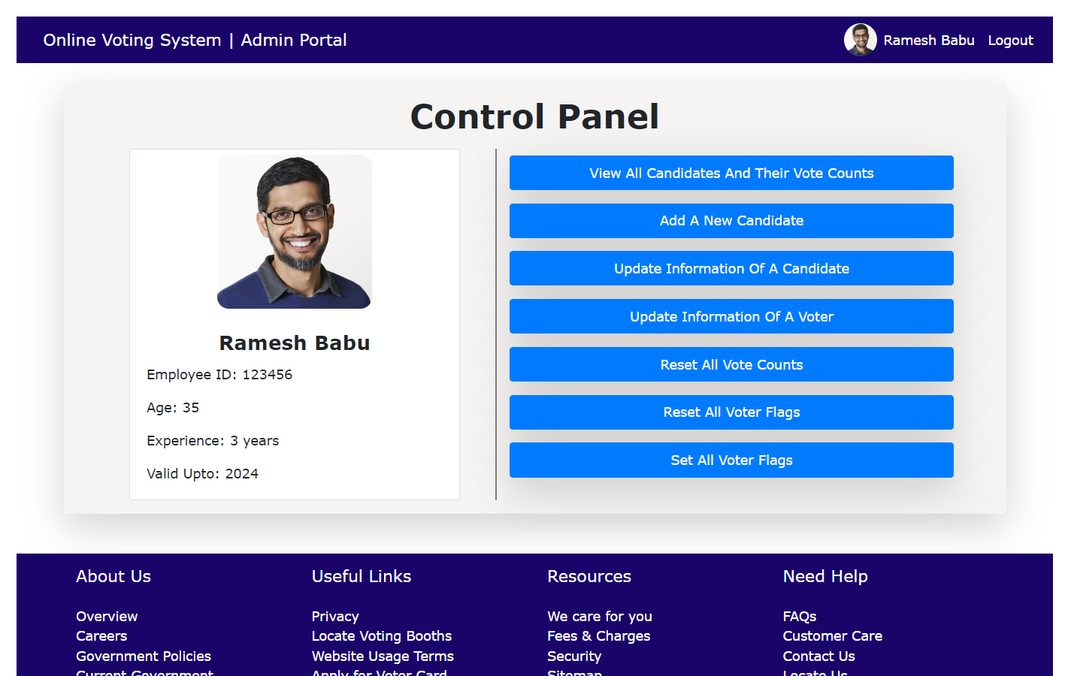

**Admin Login Page Admin Control Panel**

**Vote Count Page Create A New Candidate**

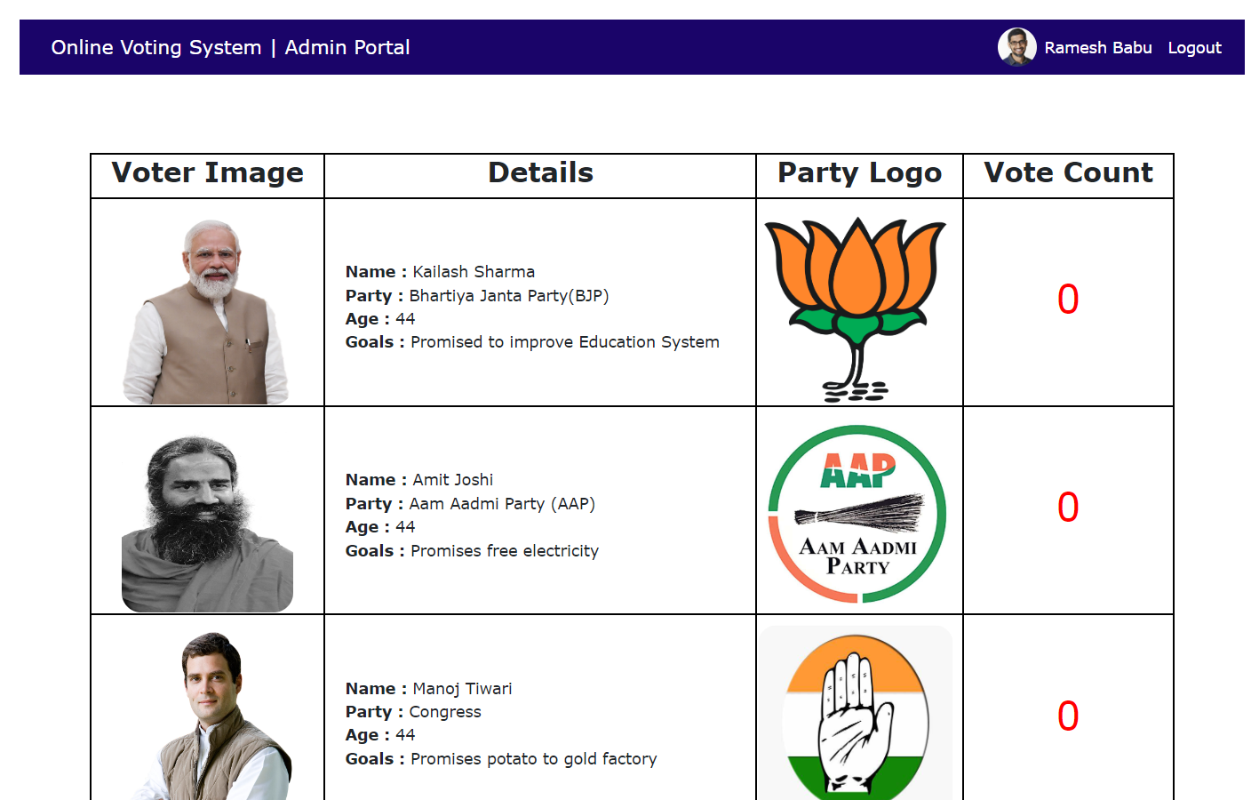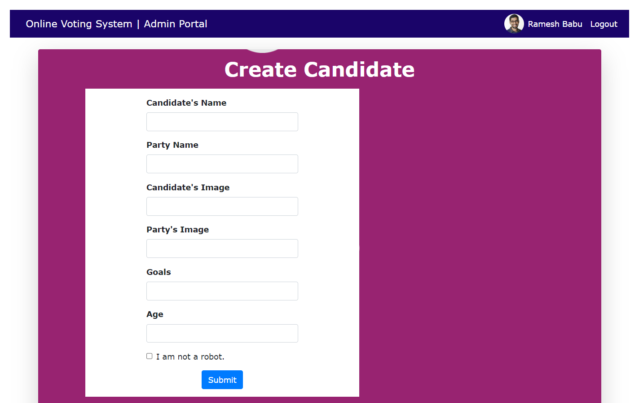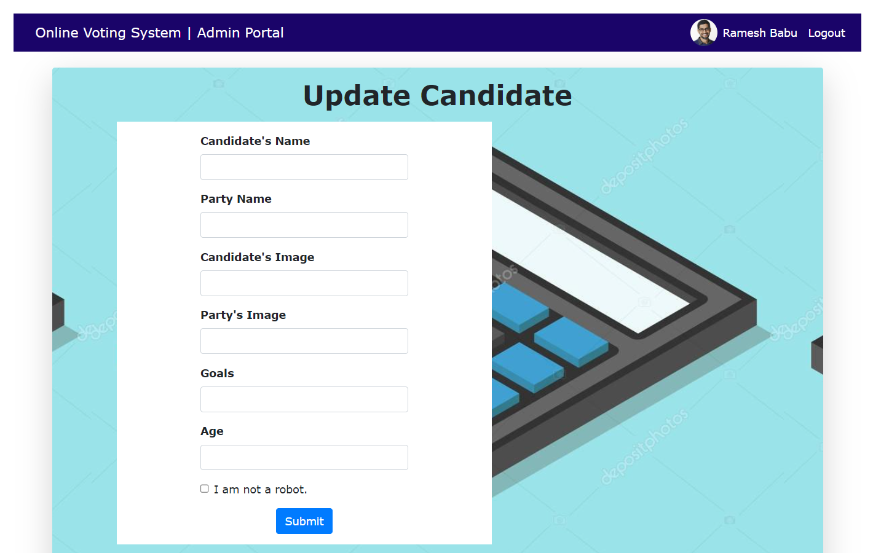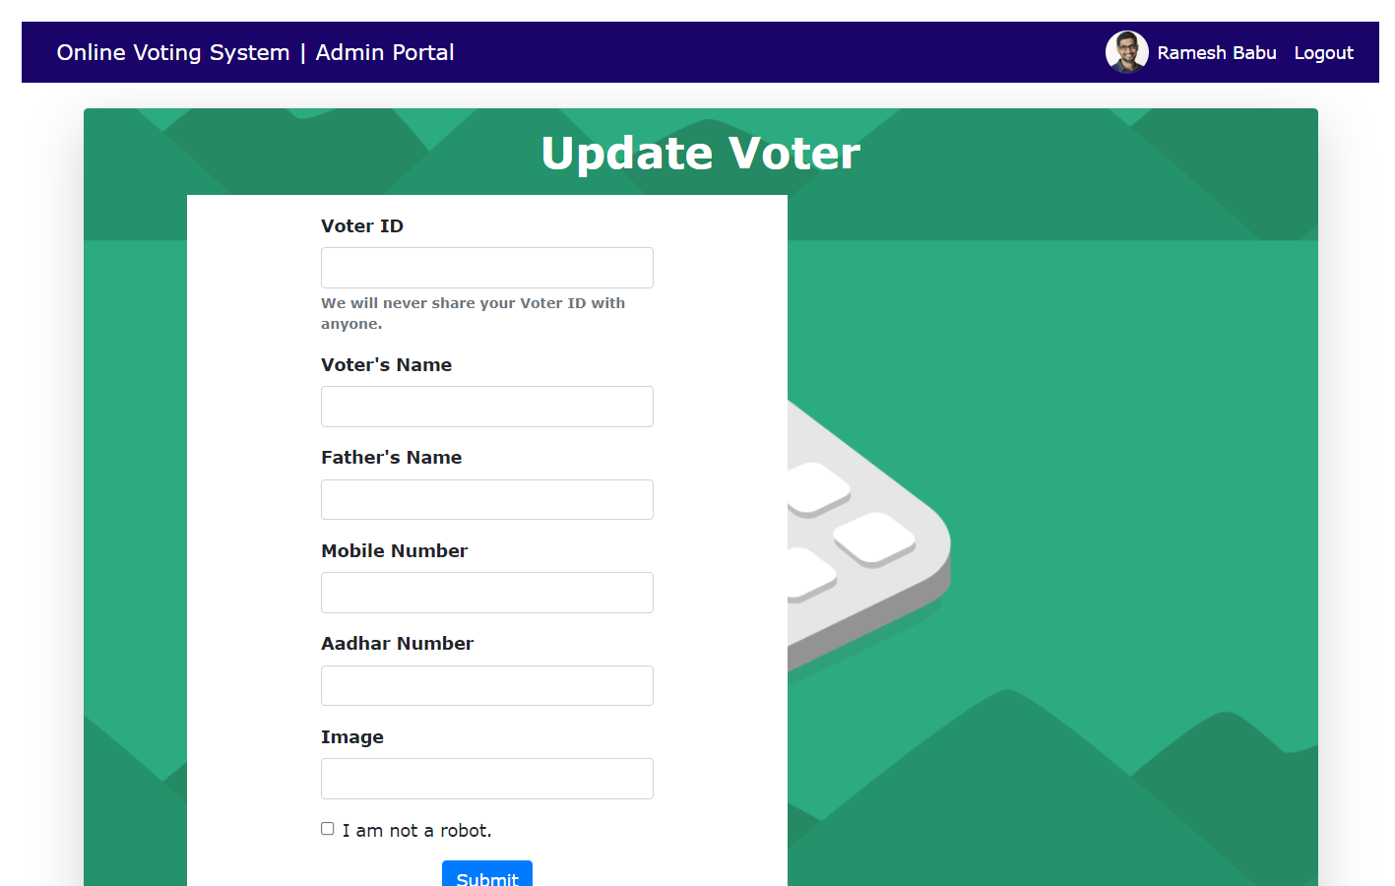

**Update Candidate Page Update Voter Page**

**REFERENCES**

1. **Code With Harry**  (<https://www.youtube.com/c/CodeWithHarry>) : For getting to know about the basic bootstrap concept.
2. **w3schools website**  (<https://www.w3schools.com/>) : For providing me knowledge and feeding me with content about PHP and mysqli and BootStrap-5.

**PROJECT LINKS**

Link to my Project On GitHub :

<https://github.com/sidbohra2001/Online-Voting-System.git>

Link to my Project On Google Drive :

<https://drive.google.com/drive/folders/1sUOmBjmjO4LLOy8aoIfs6-CwDJwuuyME?usp=sharing>